**Experiment**

**AIM**

Create a collection college and comment and do the following basic indexing operations

a.create collection college

b.insert data

c.Get all indexes

d.Create new index and show all indexs

e.Drop index and show all indexs

f.create collection comment and insert data

g.Create a text Index and sow all indexs

h.With the help of text index search on the Collection

**CODE**

**a)**

db.createCollection("college")

**b)**

db.college.insert({RegNo:2101,Name:"Raichal",Mark:[{cs:95,maths:88,phy:75,chem:85,eng:91}]})

db.college.insert({RegNo:2102,Name:"Abina",Mark:[{cs:99,maths:82,phy:76,chem:95,eng:91}]})

db.college.insert({RegNo:2103,Name:"Riya",Mark:[{cs:100,maths:85,phy:71,chem:91,eng:94}]})

**c)**

db.college.getIndexes()

**d)**

db.college.createIndex({RegNo:1})

db.college.getIndexes()

**e)**

db.college.dropIndex({RegNo:1})

db.college.getIndexes()

**f)**

db.createCollection("comment")

db.comment.insert({name:"Abina",post:"hello"})

db.comment.insert({name:"Anu",post:"hai"})

db.comment.insert({name:"Sona",post:"hola"})

db.comment.createIndex({post:"text"})

**g)**

db.comment.createIndex({post:"text"})

db.comment.getIndexes()

**h)**

db.comment.find({$text:{$search:"\"hai\""}})

OUTPUT:

**a)**



**b)**

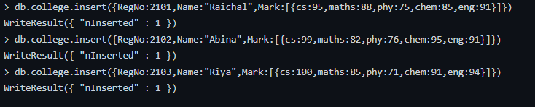

**c)**



**d)**

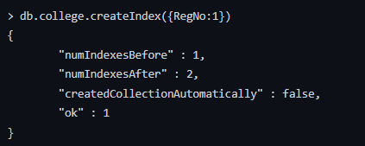

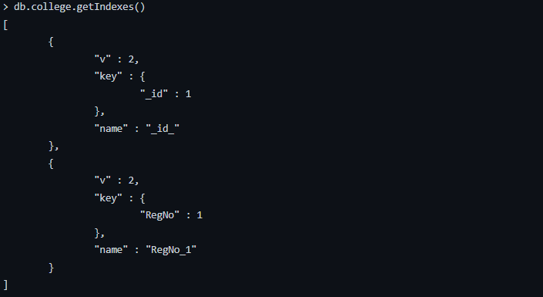

**e)**

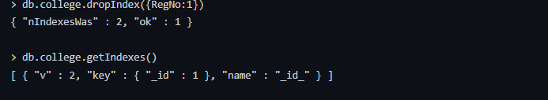

**f)**

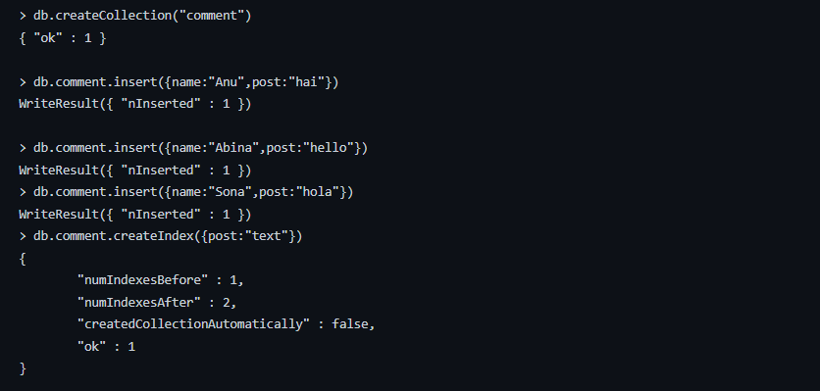

**g)**

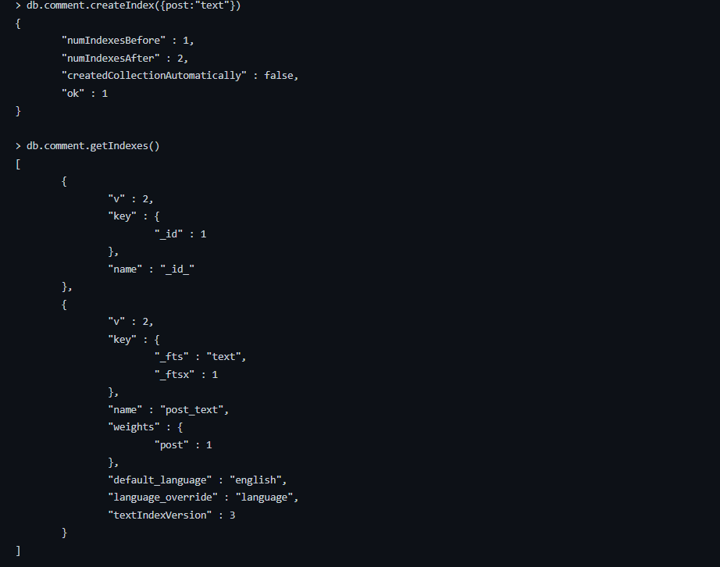

**h)**



Result:

Query processed Successfully